Lab 12: Querying Data

Part 1. Setup

Step 1. Create a schema and the tables
DROP SCHEMA IF EXISTS lab12 CASCADE;
CREATE SCHEMA lab12;
SET search_path TO lab12;
CREATE TABLE employees (
id SERIAL PRIMARY KEY,
name VARCHAR(100),
department VARCHAR(50),
salary INTEGER,
email VARCHAR(100)
);
CREATE TABLE sales (
id SERIAL PRIMARY KEY,
employee_id INTEGER REFERENCES employees(id),
amount INTEGER
);

Step 2. Insert sample data
INSERT INTO employees (name, department, salary, email) VALUES
('Aibek Sharshenov', 'Engineering', 95000, 'aibek.sh@gmail.com'),
('Ainura Toktomamatova', 'Sales', 62000, 'ainura@GMAIL.com'),
('Bakyt Mamatov', 'Engineering', 120000, 'bakyt.m@company.kg'),
('Gulzat Sultanova', 'Sales', 48000, 'gulzat@mail.ru'),
('Emir Uulu', 'Marketing', 71000, NULL),
('Meerim Bekova', 'Engineering', 58000, 'meerim.bekova@gmail.com'),
('Tilek Usubaliev', 'Marketing', 105000, 'tilek.company.kg');
INSERT INTO sales (employee_id, amount) VALUES
(2, 1500), (2, 800), (4, 1200), (5, 300), (7, 2500);
SELECT * FROM employees;
SELECT * FROM sales;
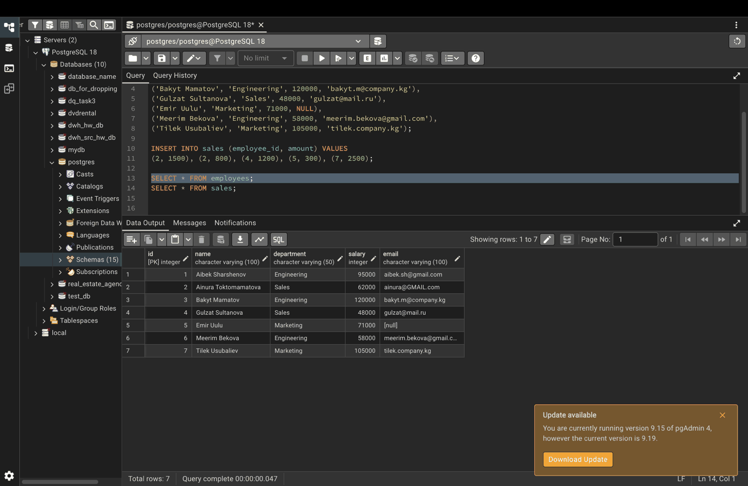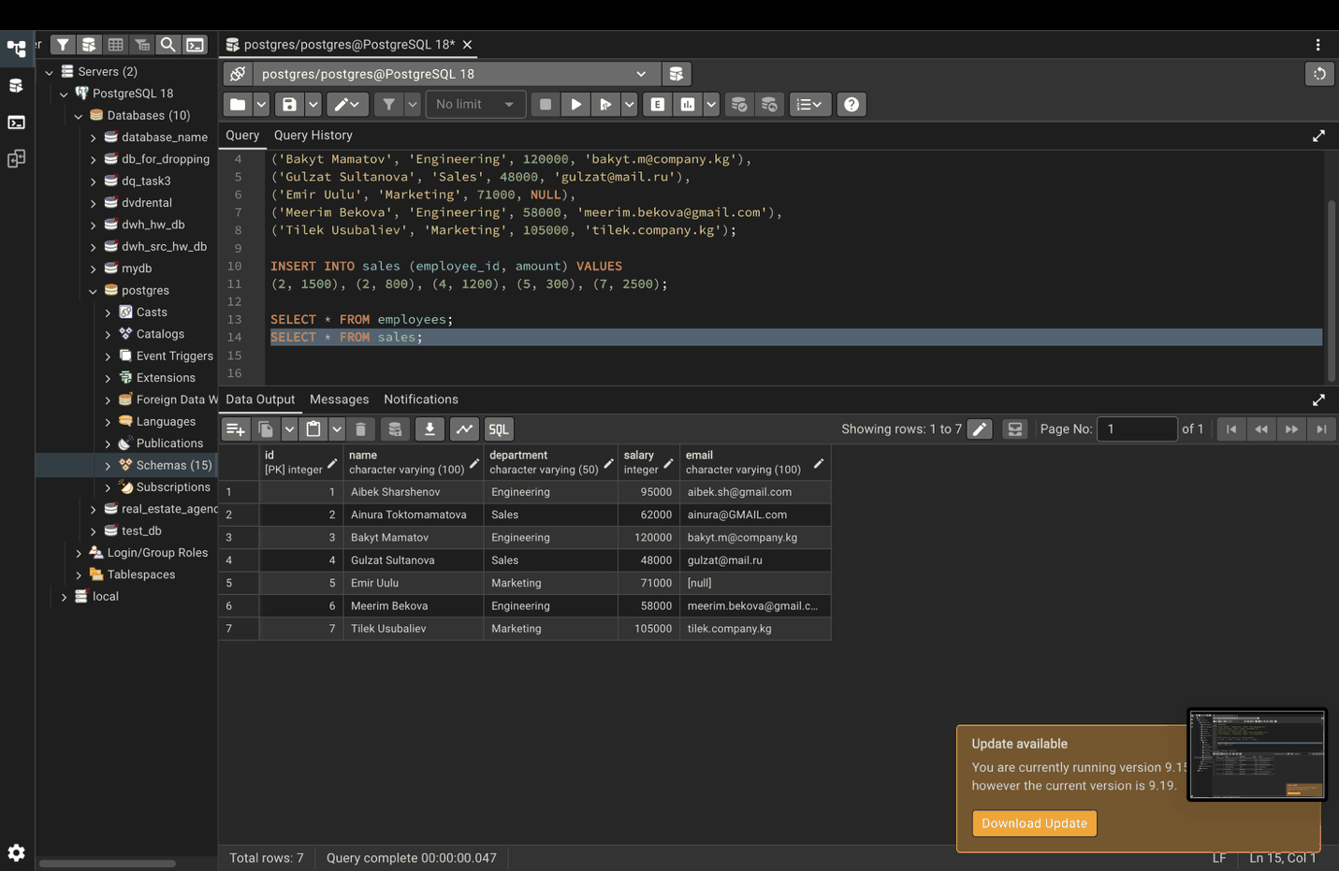

Part 2. SELECT statements

Step 3. Select specific columns
SELECT name, department FROM employees;
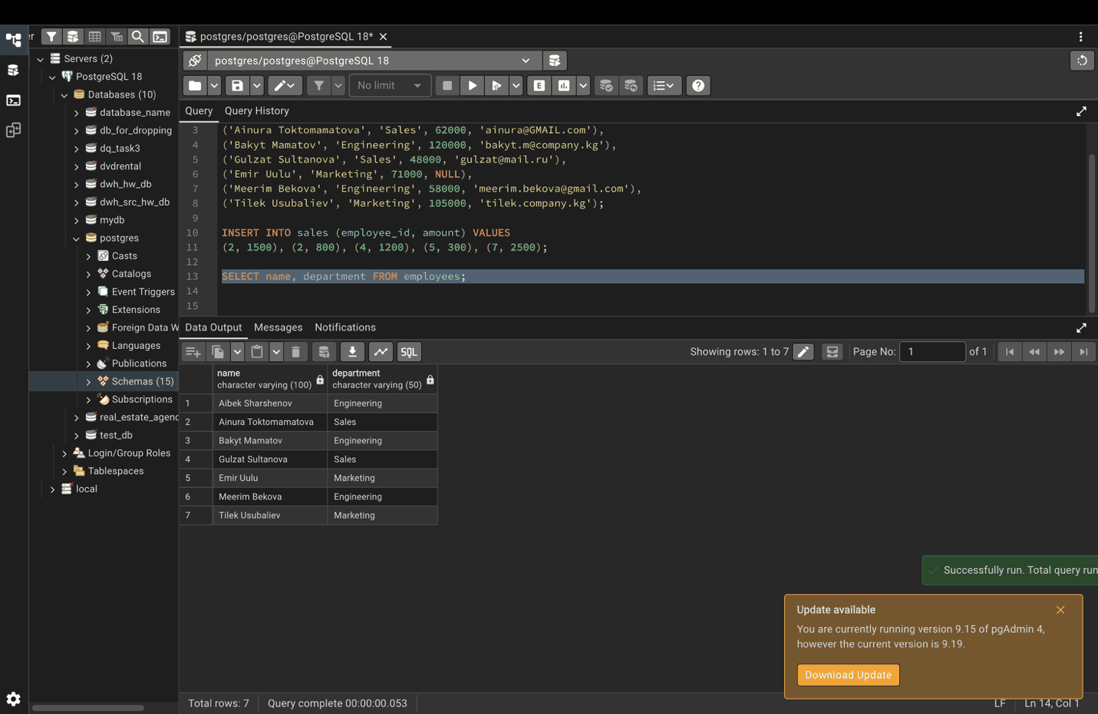

Step 4. Calculate a 10% bonus with AS
AS renames the calculated column in the output.
SELECT name, salary, salary * 0.10 AS potential_bonus
FROM employees;
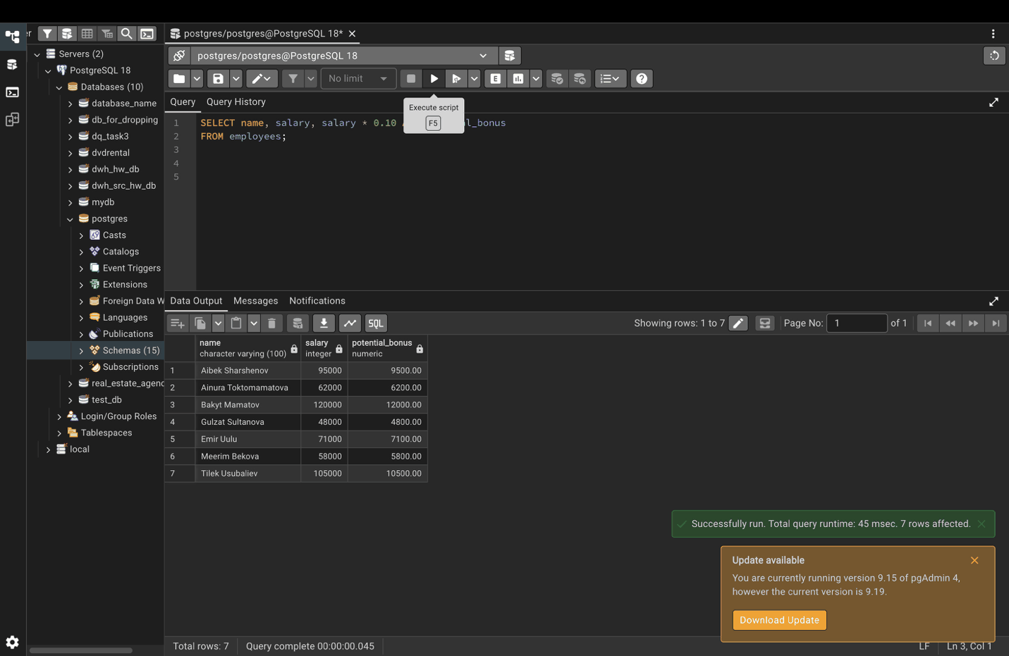

Part 3. WHERE clause

Step 5. Employees in the Sales department
SELECT name, salary
FROM employees
WHERE department = 'Sales';
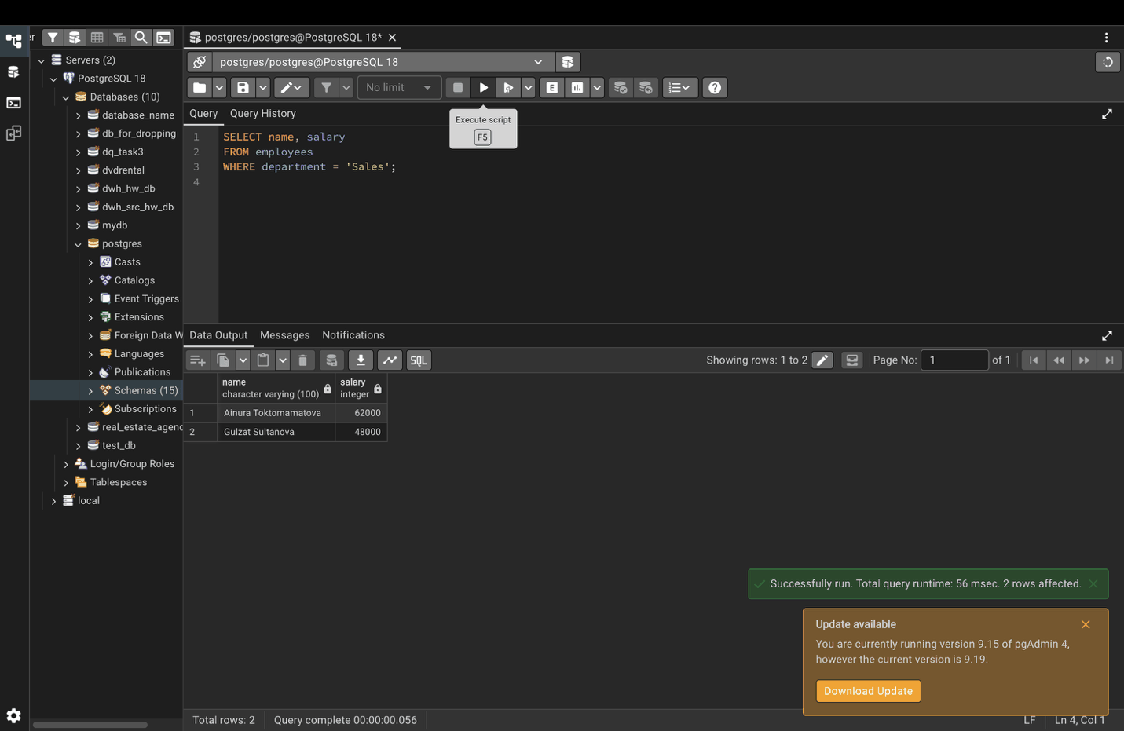

Step 6. Combine conditions with AND
SELECT name
FROM employees
WHERE salary > 75000 AND department = 'Engineering';
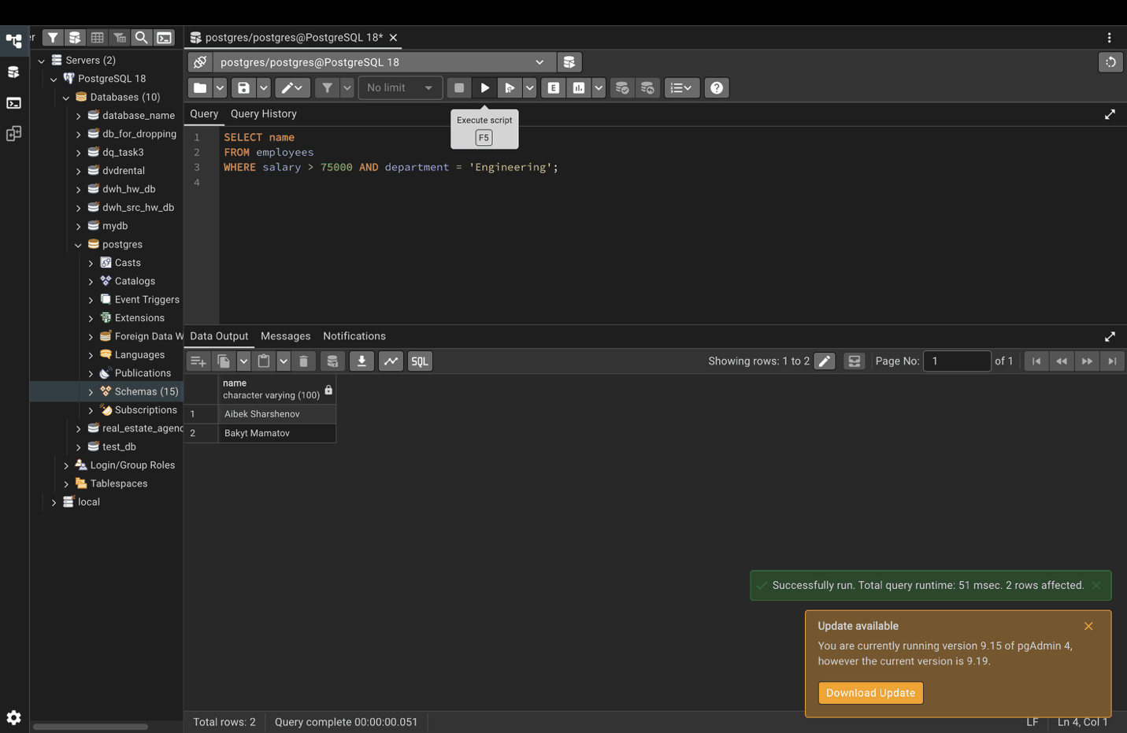

Step 7. Range with BETWEEN
SELECT name, salary
FROM employees
WHERE salary BETWEEN 60000 AND 100000;
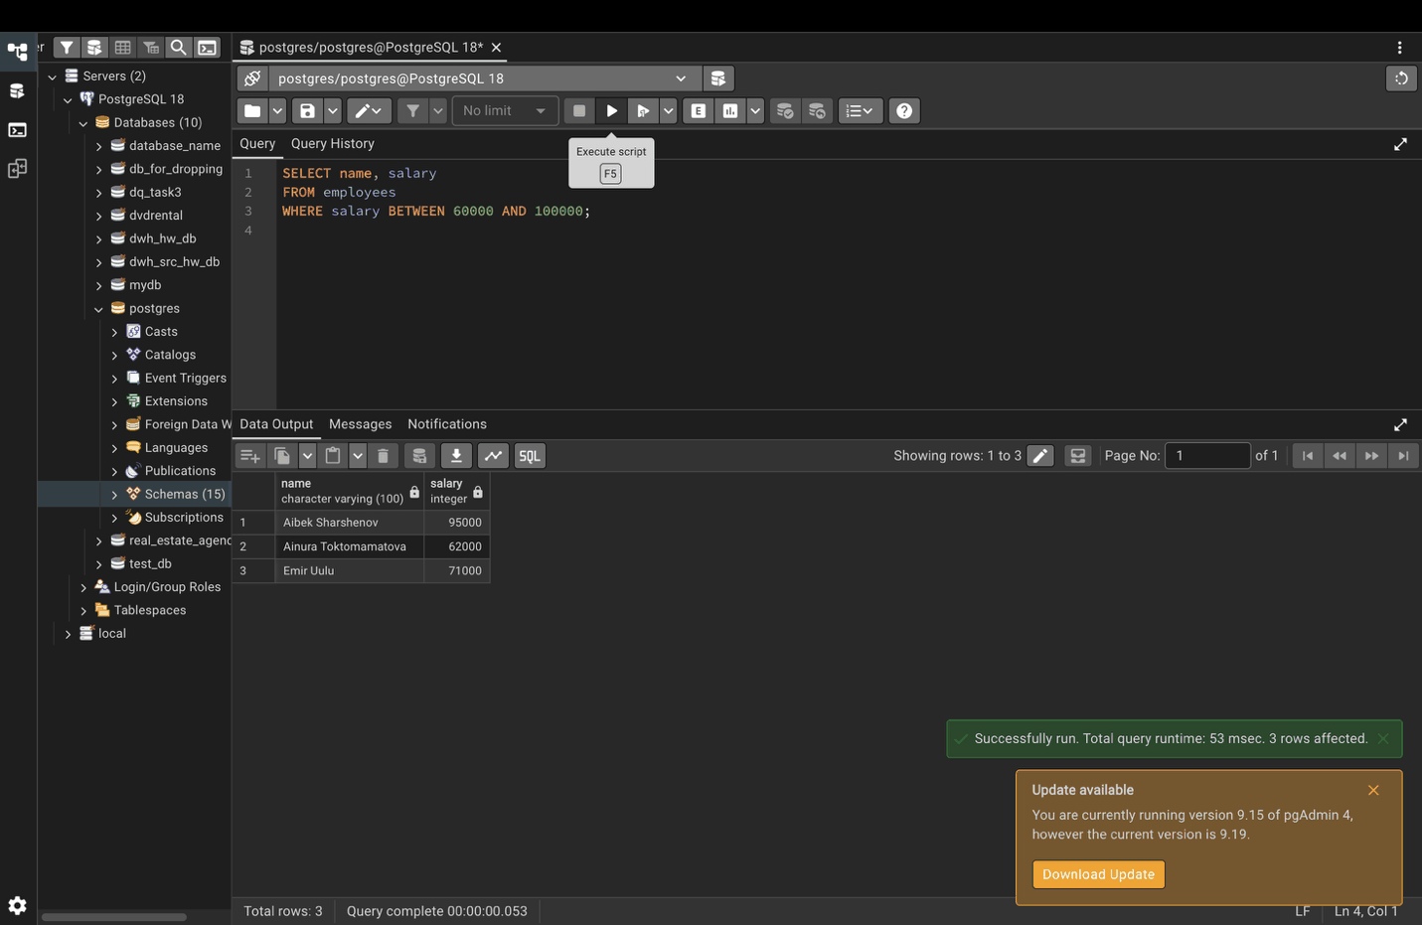

Step 8. Check for NULL
SELECT name, email
FROM employees
WHERE email IS NULL;
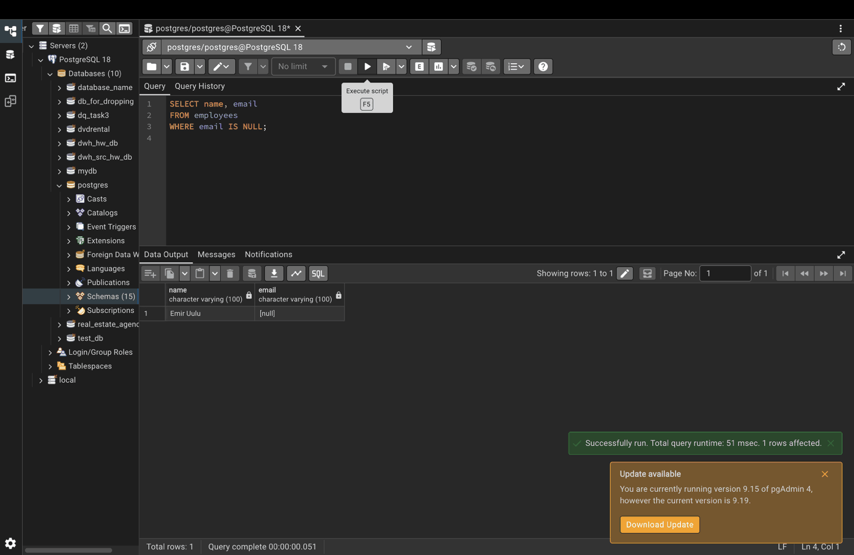

Part 4. Pattern matching (LIKE, ILIKE)

Step 9. Names starting with "A"
SELECT name
FROM employees
WHERE name LIKE 'A%';
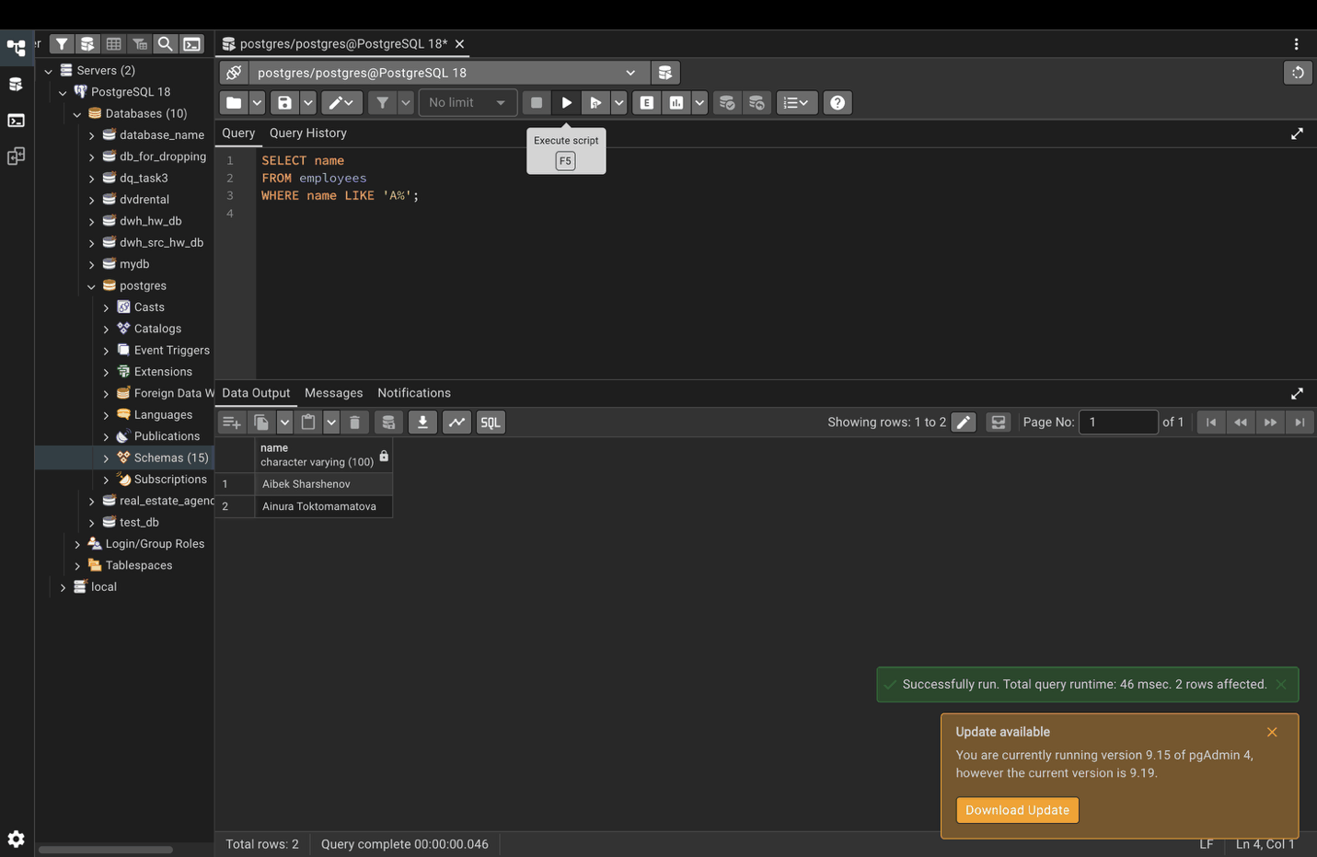

Step 10. Names ending with "ova"
SELECT name
FROM employees
WHERE name LIKE '%ova';
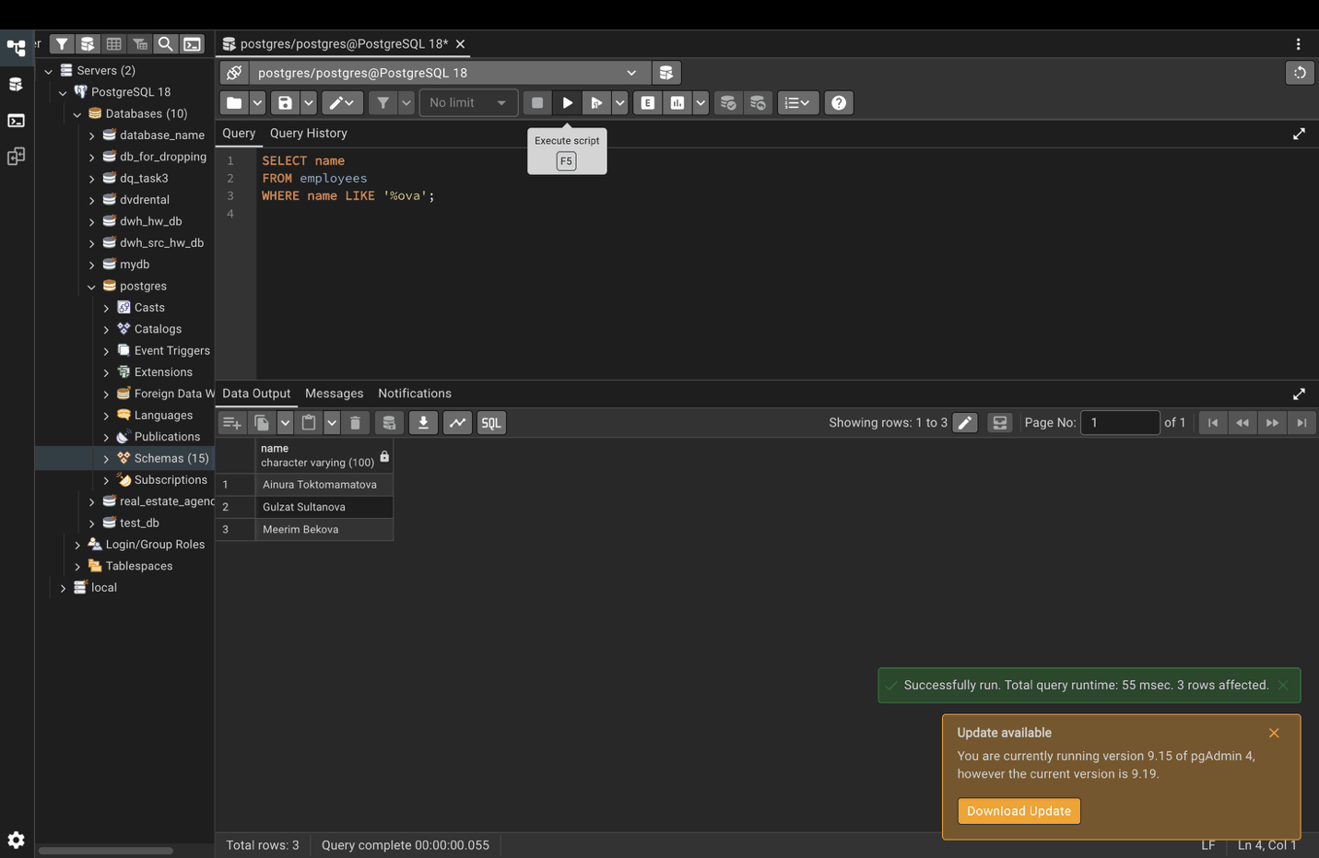

Step 11. Gmail addresses (case-insensitive)
ILIKE also finds ainura@GMAIL.com, which LIKE would miss.
SELECT email
FROM employees
WHERE email ILIKE '%@gmail.com';
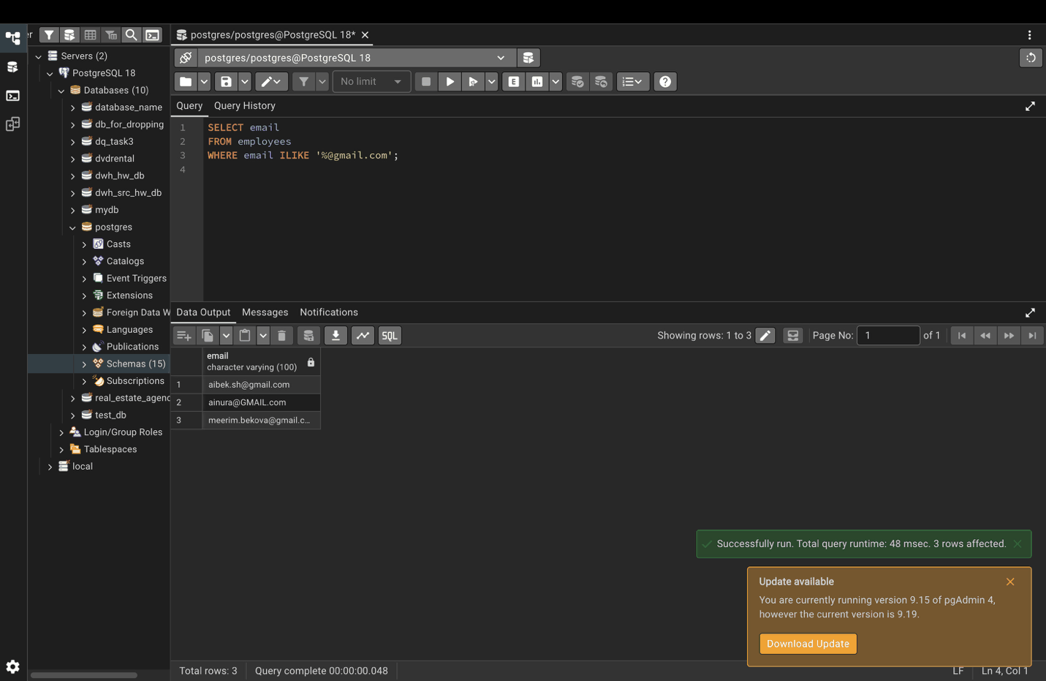

Part 5. Regular expressions

Step 12. Names starting with A or B
SELECT name
FROM employees
WHERE name ~ '^[AB]';
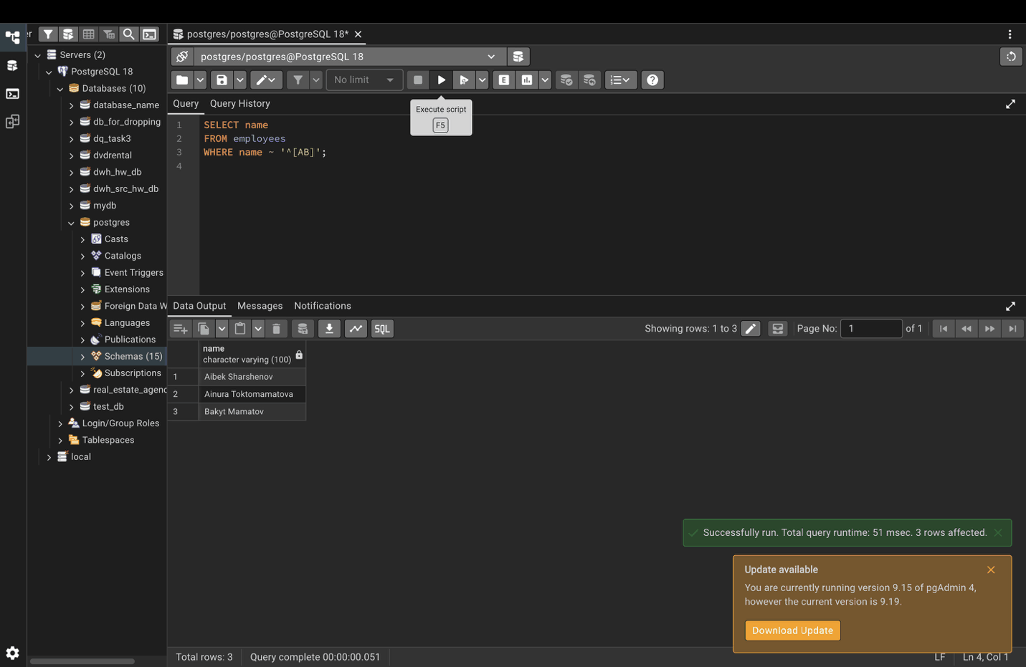

Step 13. Valid email addresses
tilek.company.kg has no @, so it is not returned.
SELECT email
FROM employees
WHERE email ~* '^[A-Z0-9._%+-]+@[A-Z0-9.-]+\.[A-Z]{2,}$';
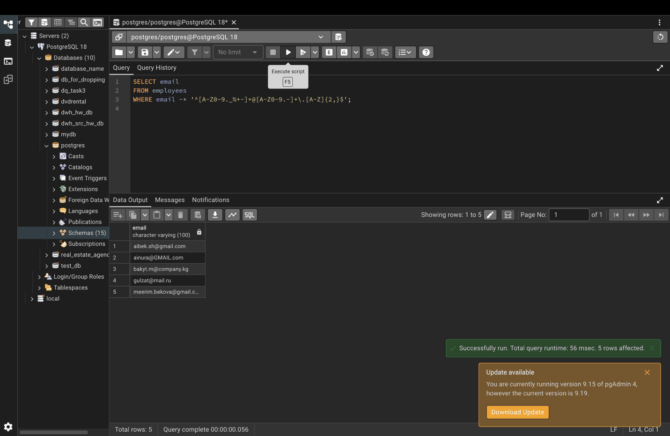

Part 6. IN and EXISTS

Step 14. IN with a list
SELECT name, department
FROM employees
WHERE department IN ('Sales', 'Marketing');
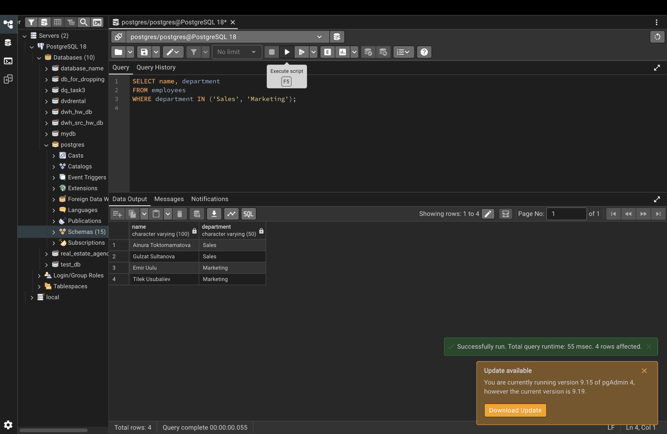

Step 15. IN with a subquery
SELECT name
FROM employees
WHERE id IN (SELECT employee_id FROM sales WHERE amount > 1000);
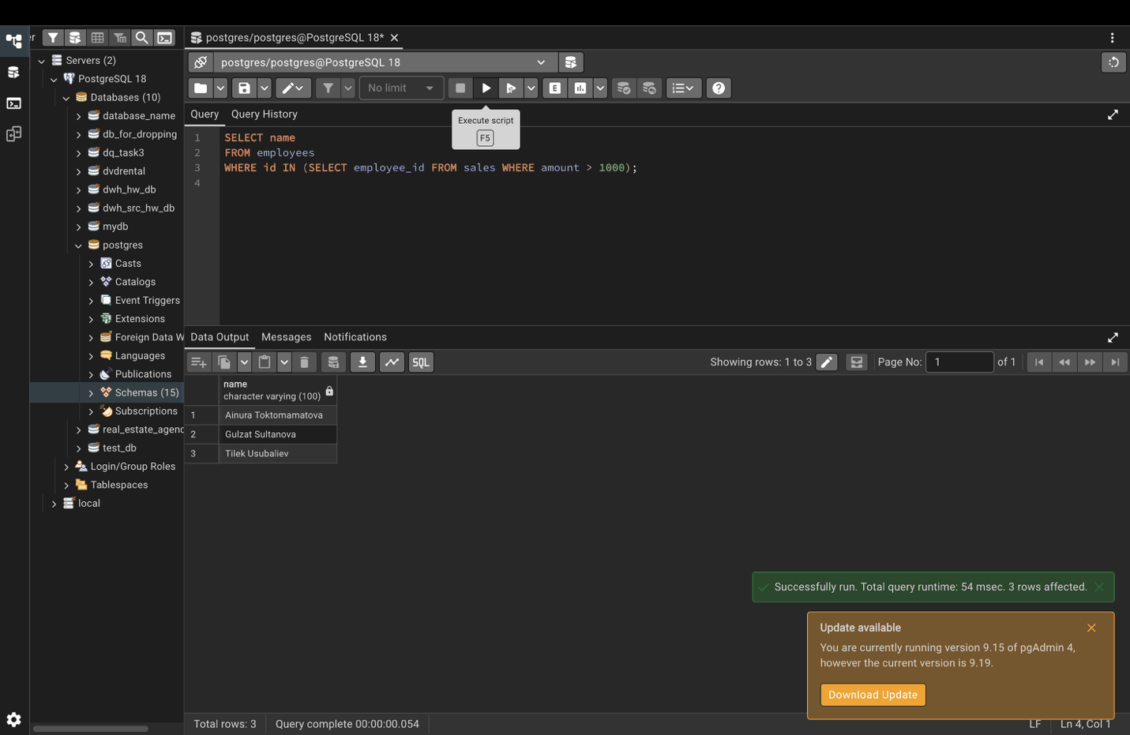

Step 16. EXISTS
SELECT name
FROM employees e
WHERE EXISTS (
SELECT 1
FROM sales s
WHERE s.employee_id = e.id AND s.amount > 1000
);
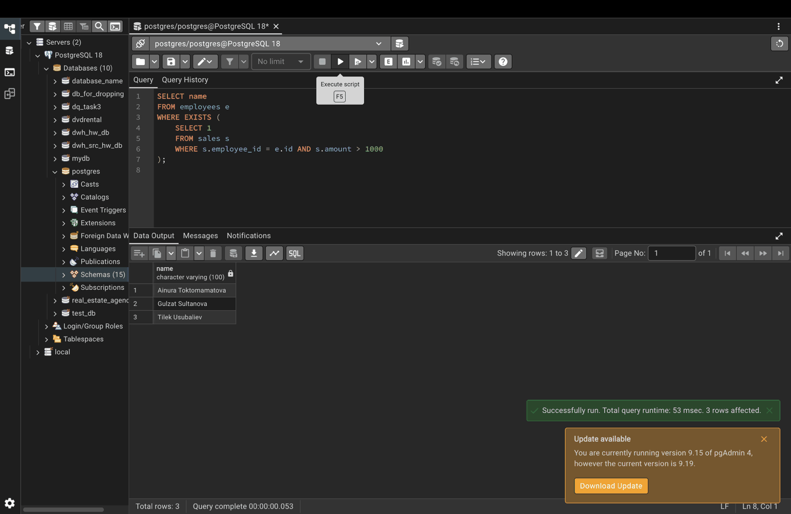

Part 7. CASE statements

Step 17. Classify employees by salary
SELECT name, salary,
CASE
WHEN salary > 100000 THEN 'Senior'
WHEN salary BETWEEN 60000 AND 100000 THEN 'Mid-Level'
ELSE 'Junior'
END AS employee_level
FROM employees;
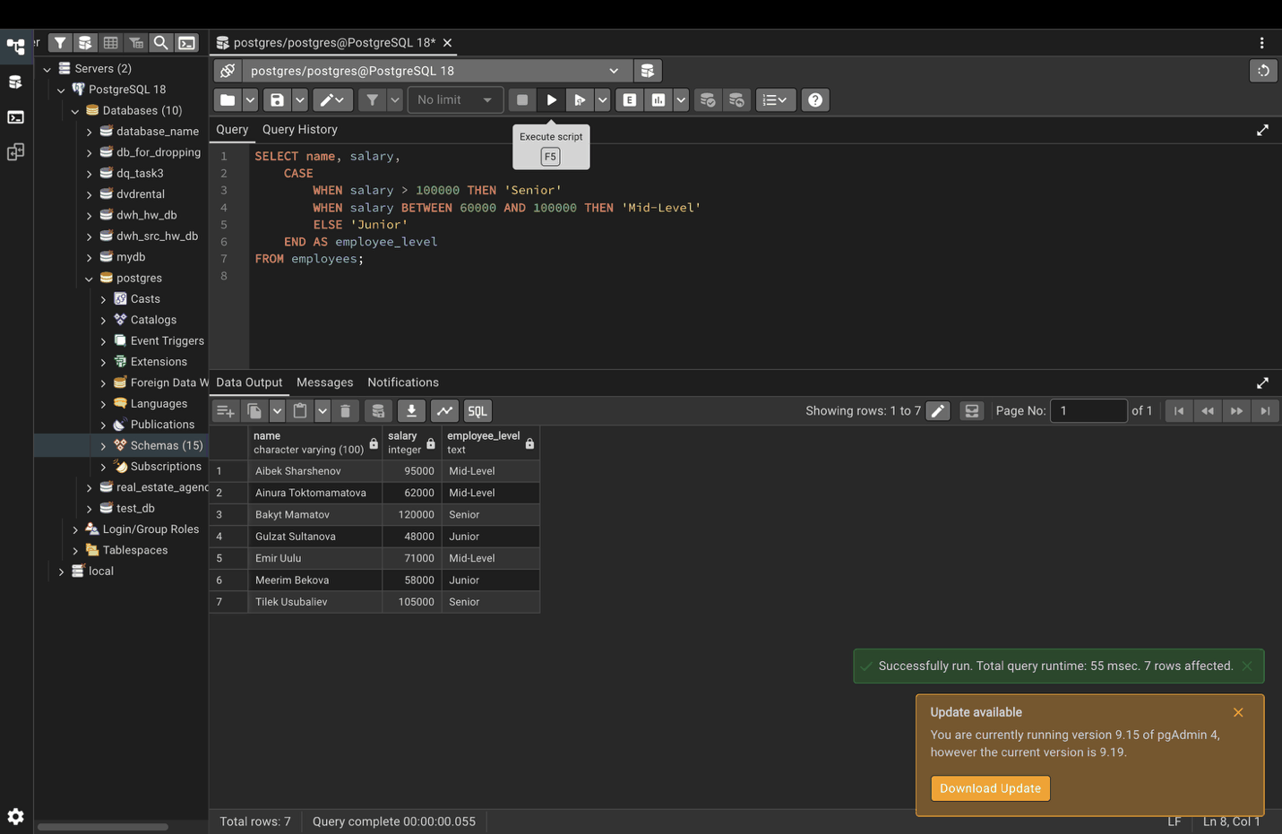

Part 8. Common Table Expressions (CTEs)

Step 18. Employees earning above their department average
WITH department_averages AS (
SELECT department, AVG(salary) AS avg_salary
FROM employees
GROUP BY department
)
SELECT e.name, e.salary, e.department, da.avg_salary
FROM employees e
JOIN department_averages da ON e.department = da.department
WHERE e.salary > da.avg_salary;


